Exploring AWS Organizations and IAM Identity Center for Centralized SSO Access
Step 1: Go to the AWS organizations console and click on create an organization. Then Confirm it again in the next console.
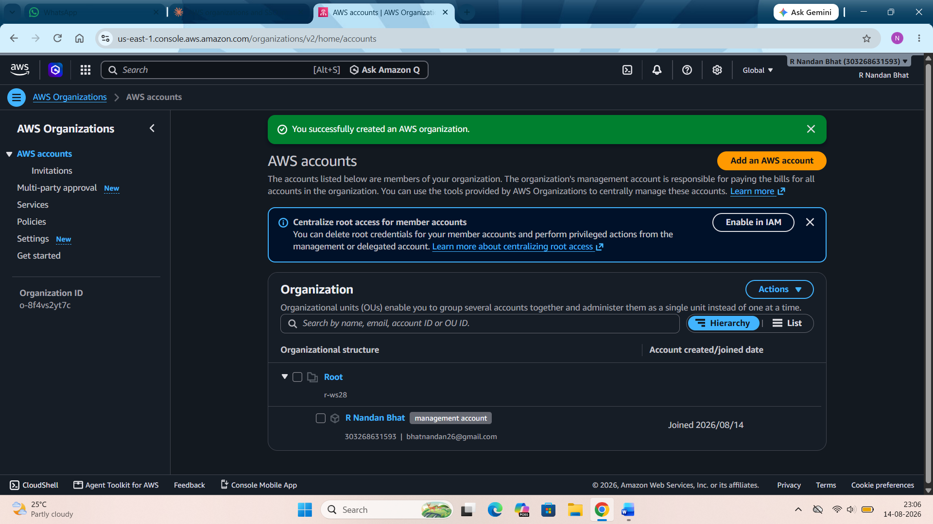
Step 2: Then create a AWS account in this. Name it and set the email address and give the required name for the role as well. Then click on create AWS account.

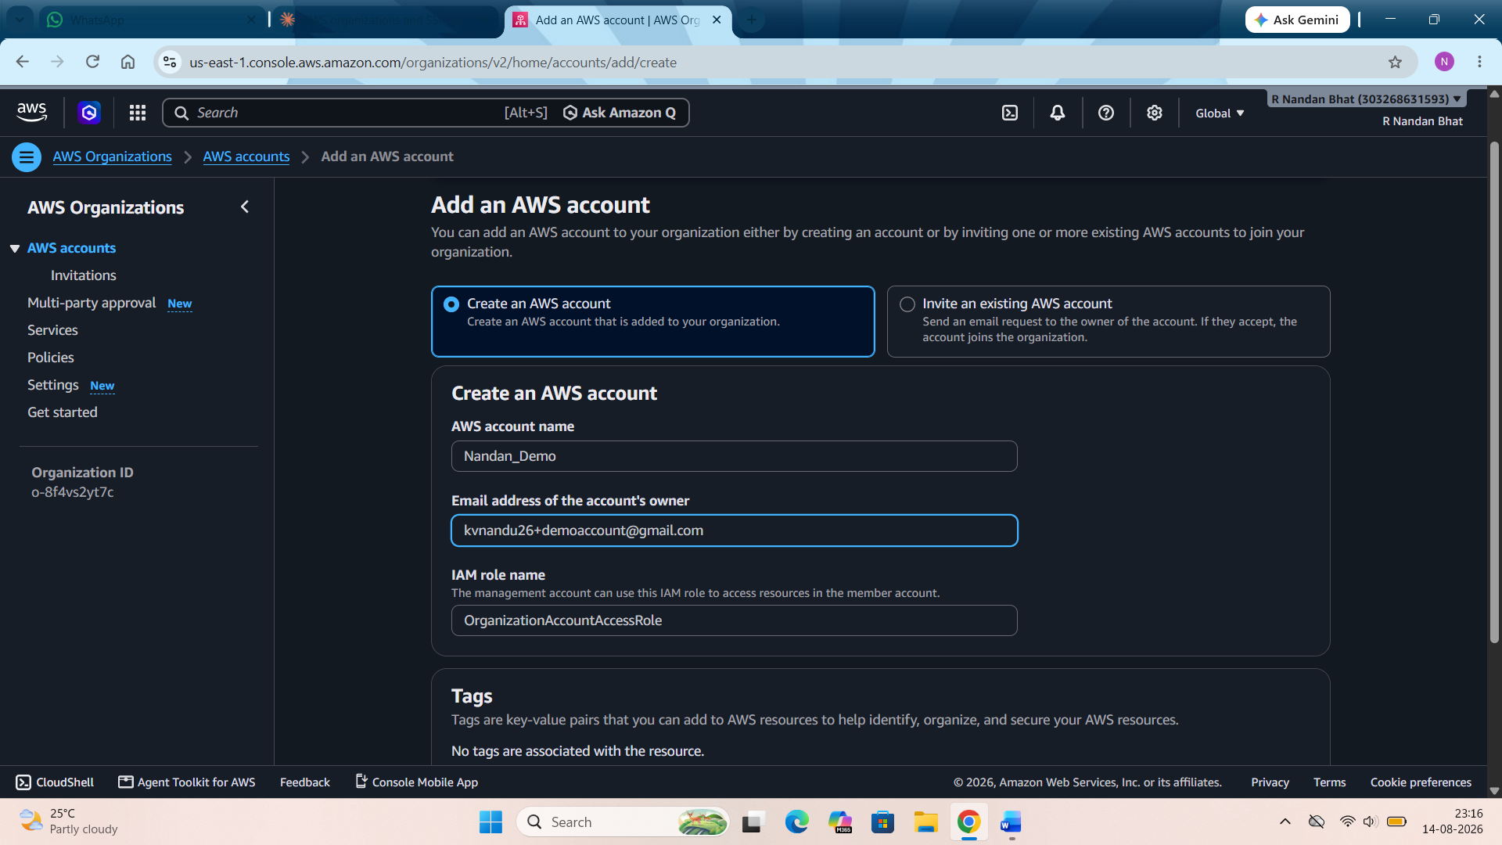

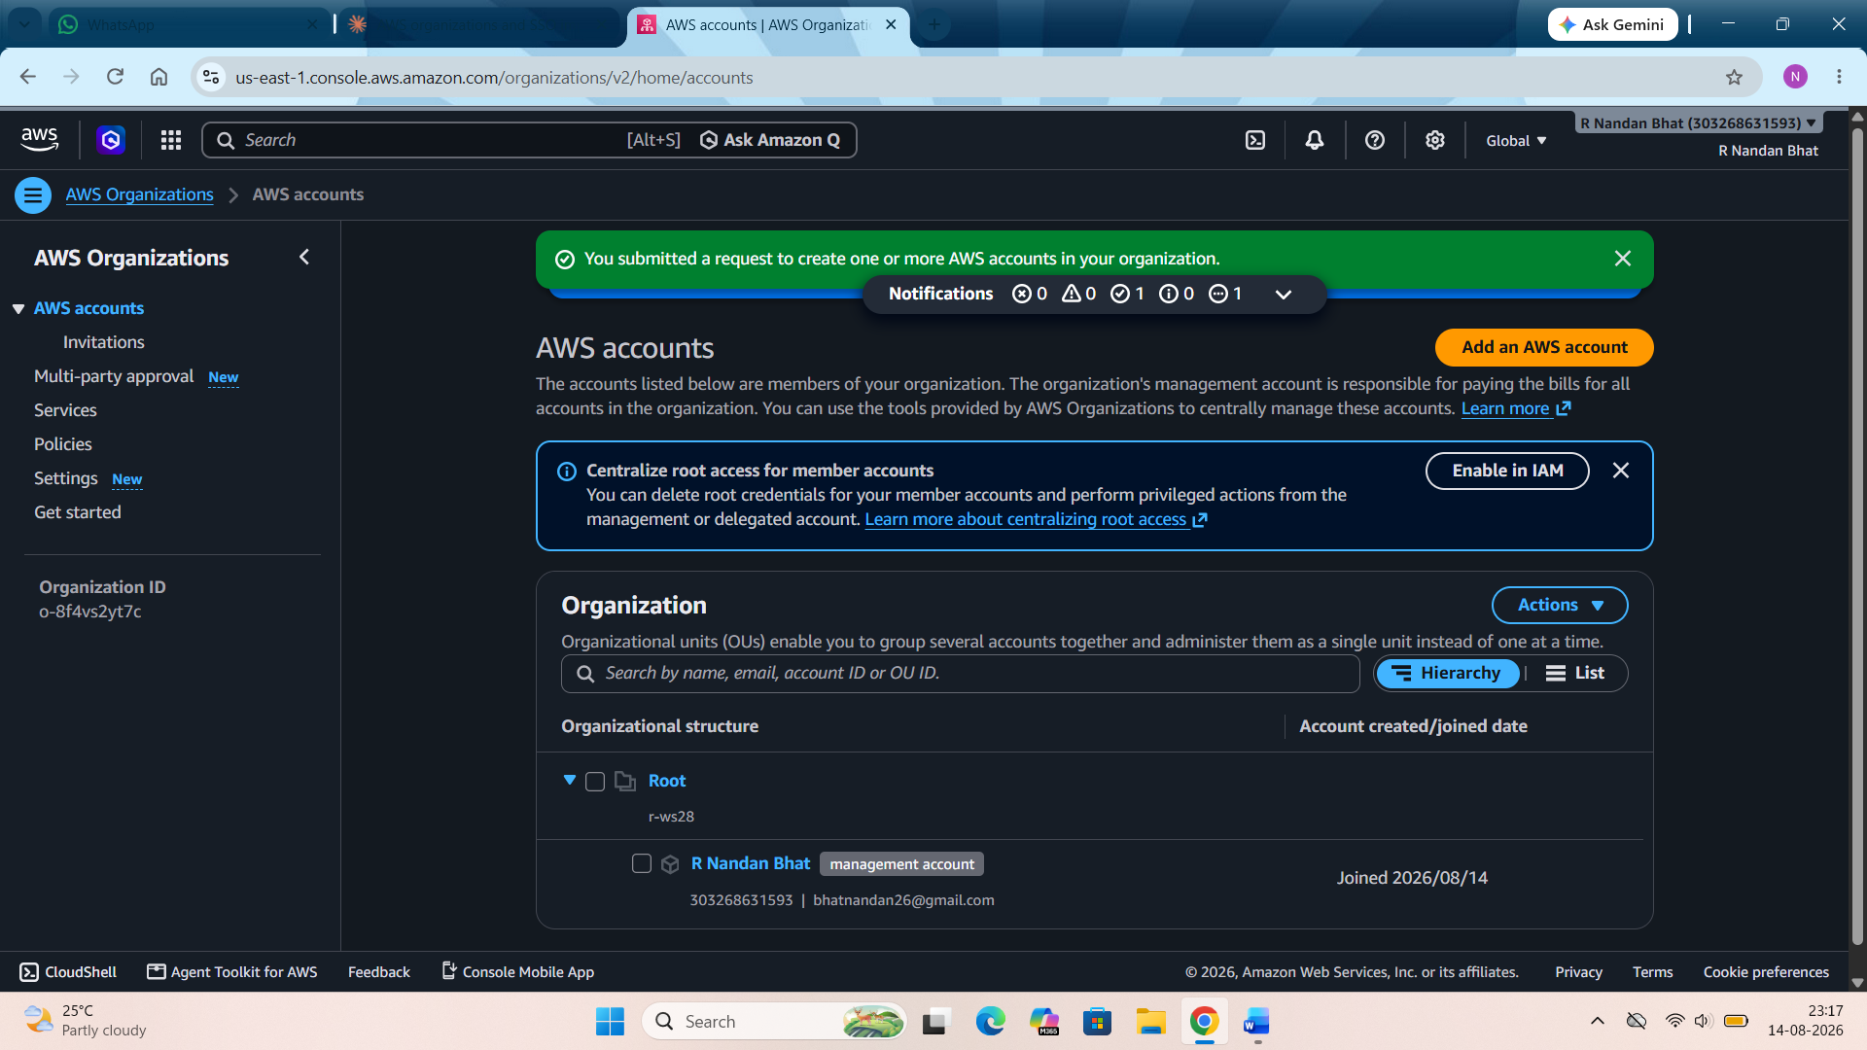
Step 3: Go to IAM Identity Center console → Enable. Since Organizations now exists, this creates an organization instance automatically. Copy the AWS access portal URL from the Settings summary box.

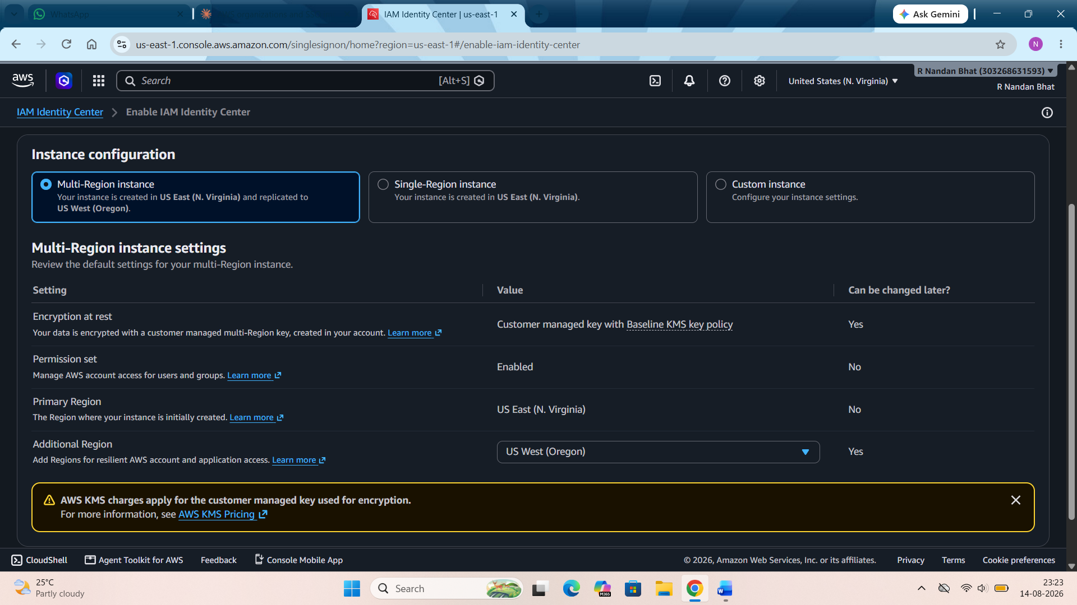
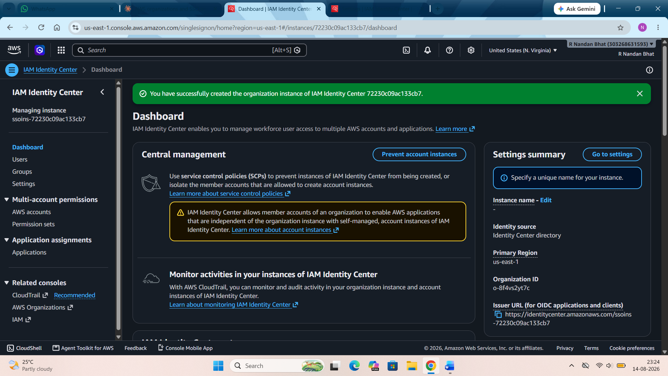
If we have enabled the multi region instance then we can see if its deployed or not in settings.

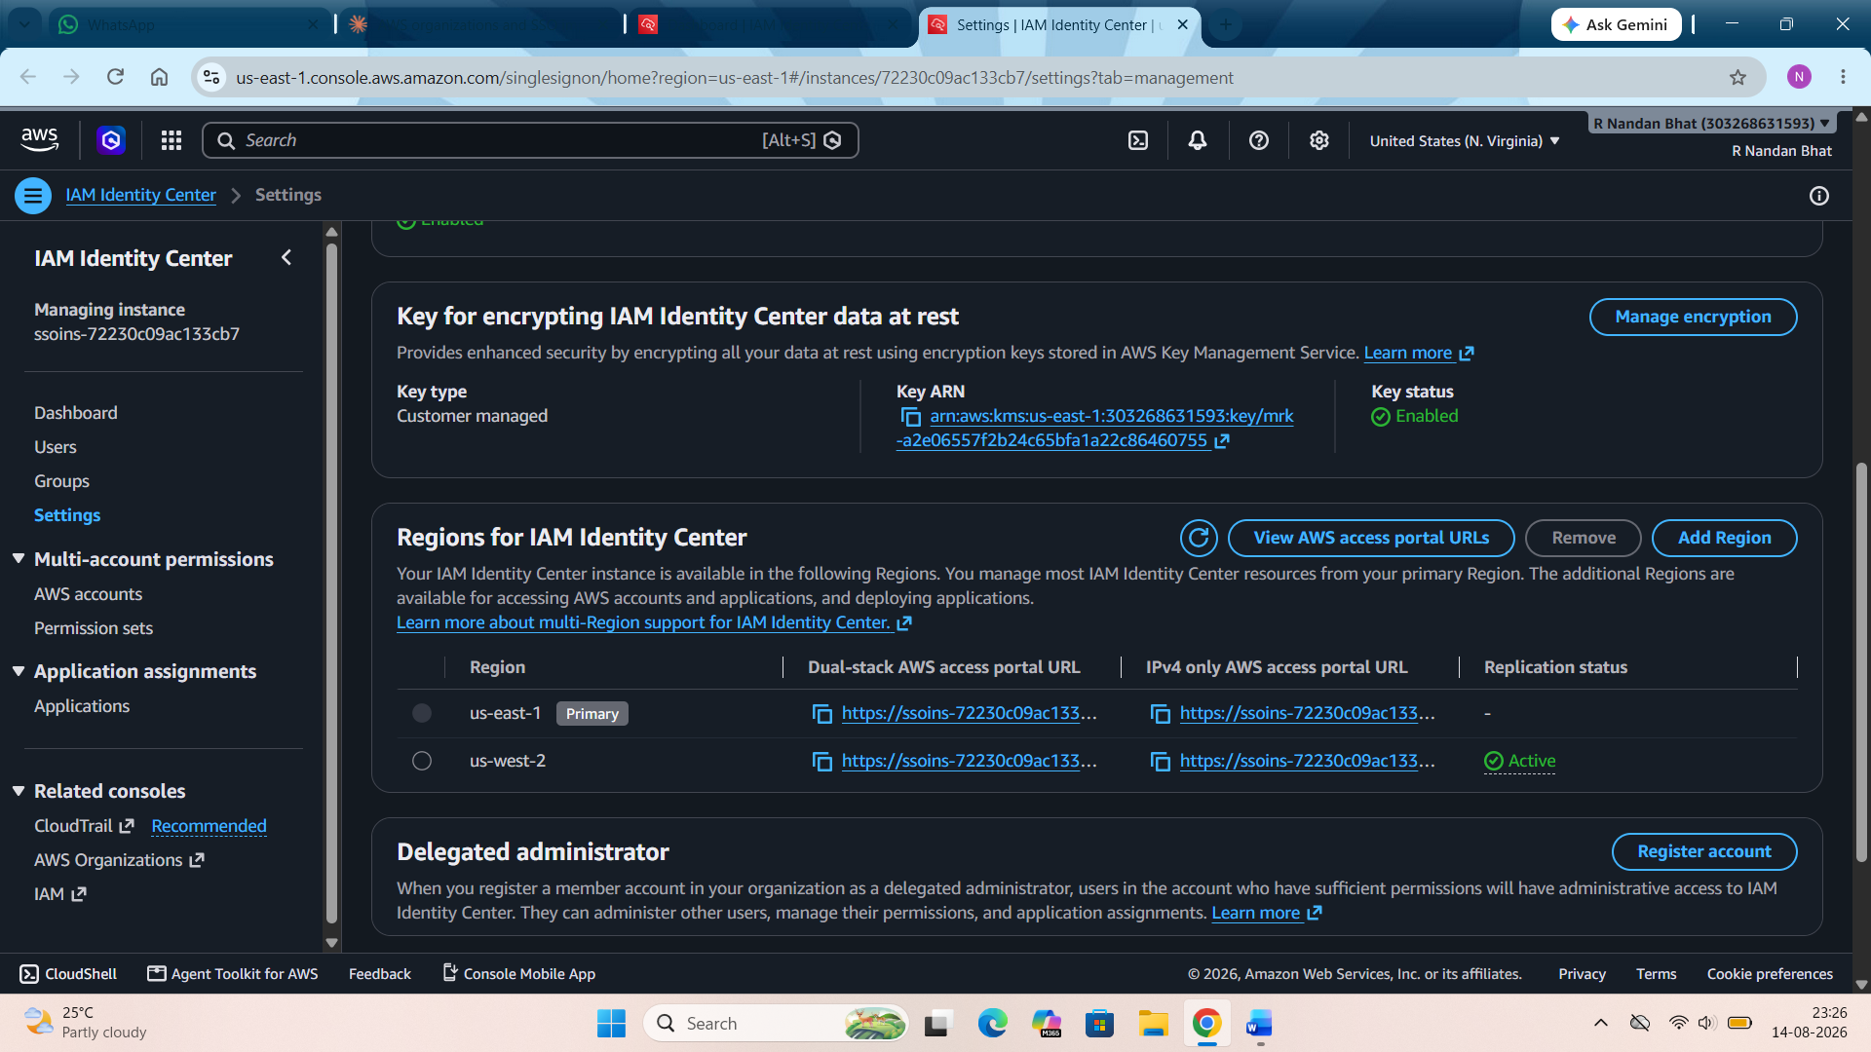

Step 4: Create an SSO user. That is User --- add user and then fill all the required details. Click next.
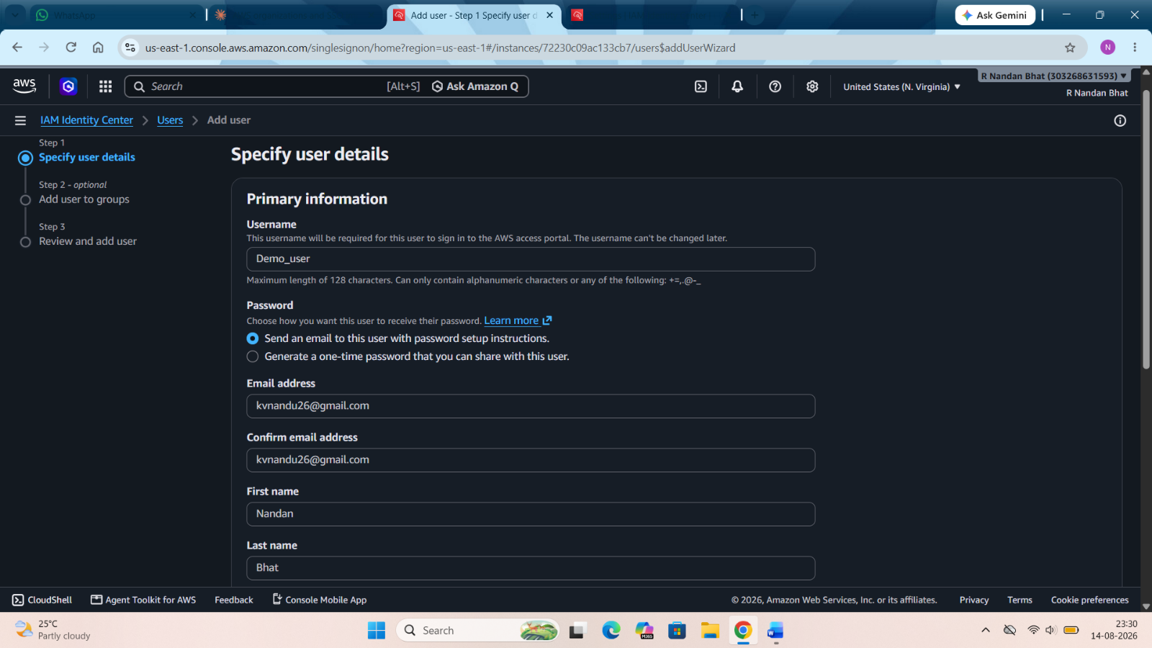
AWS will send a link to the given mail id to set up the password.
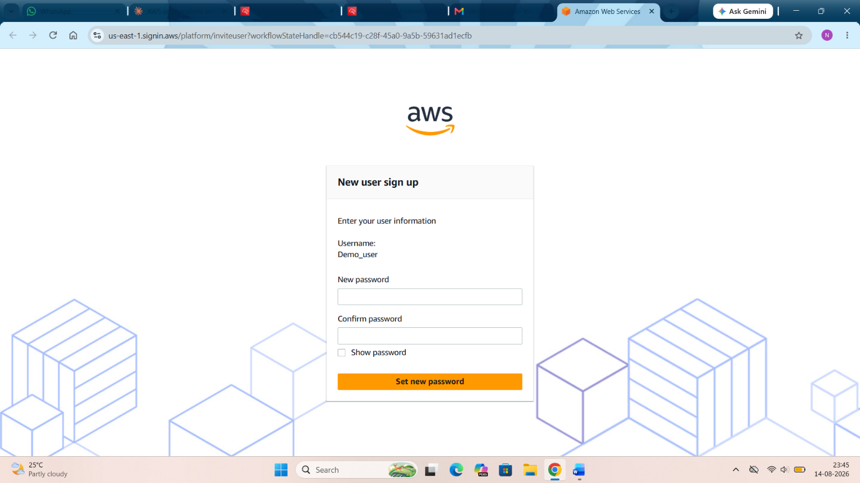

Step 5: Create a permission set. Left sidebar → Permission sets → Create permission set. Choose Predefined permission set. Select AdministratorAccess or any other required permission. Click through and finish creating it.

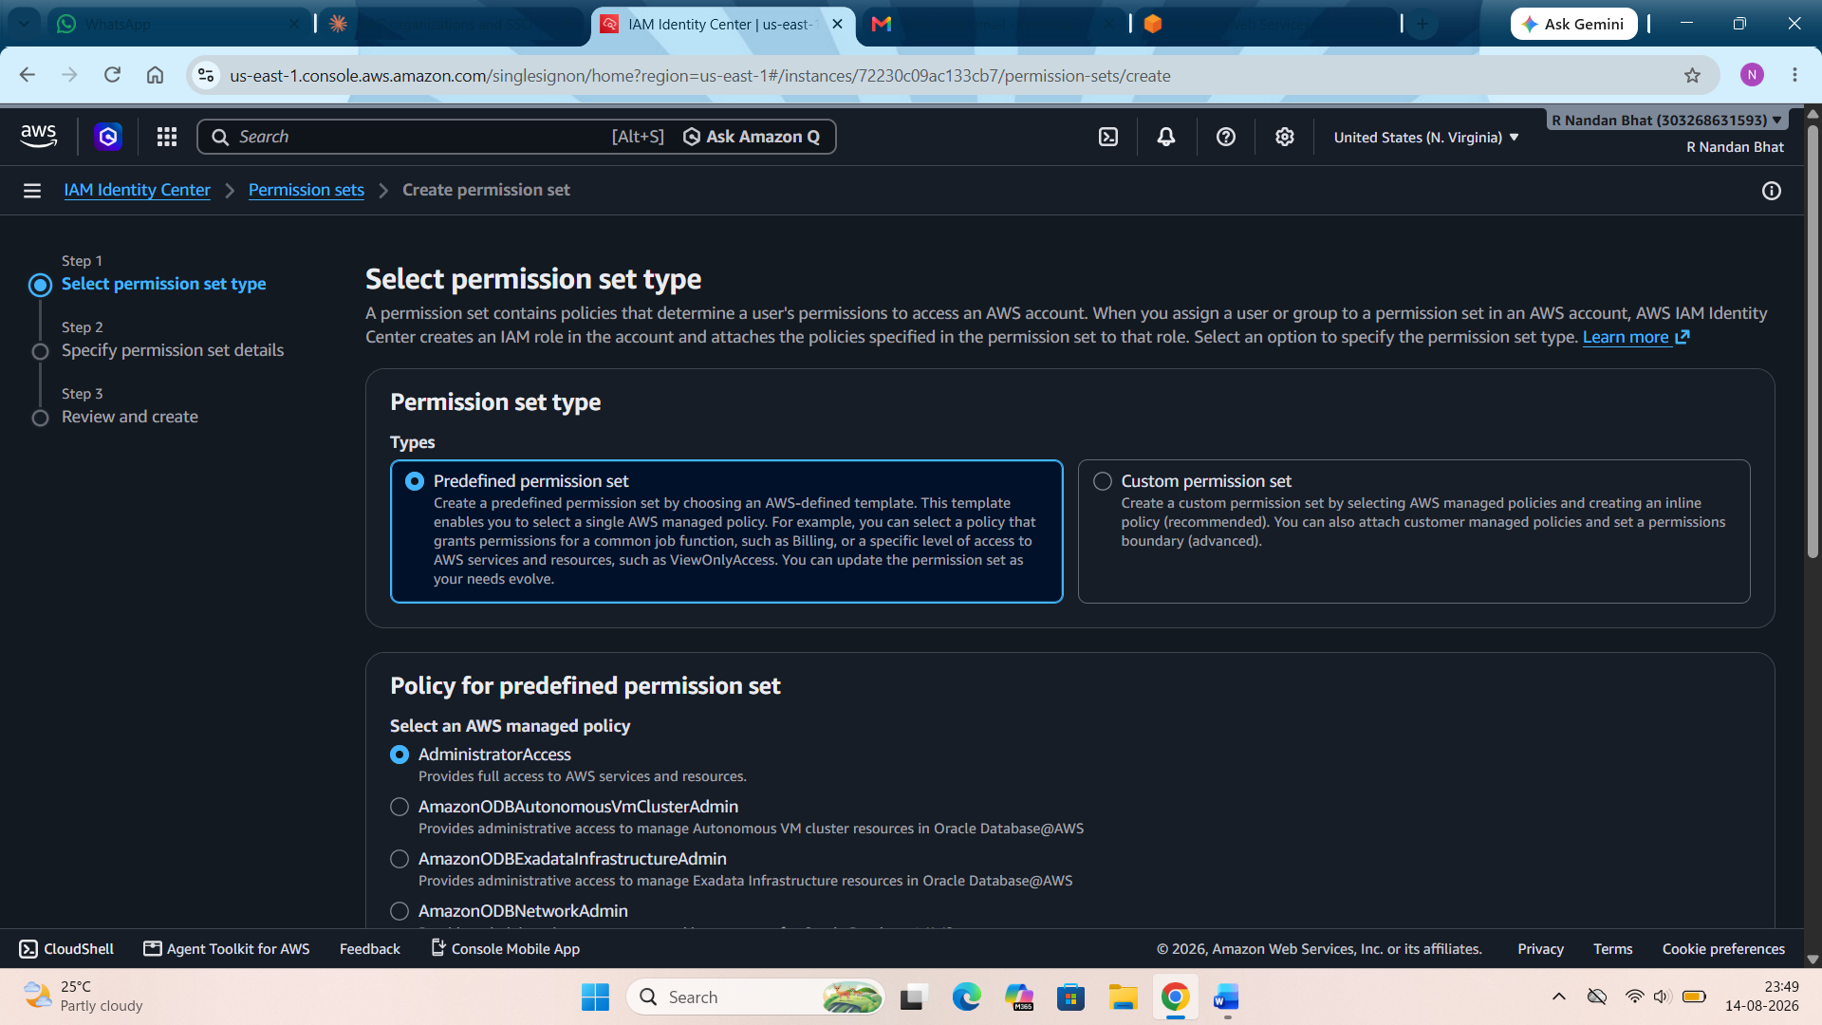

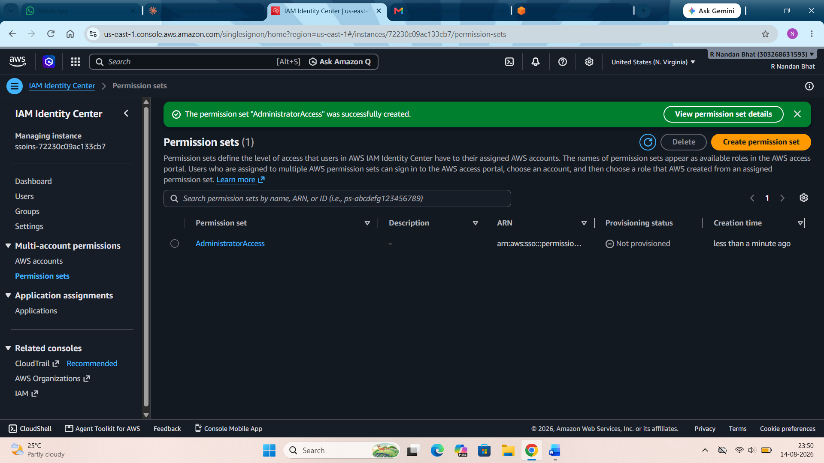

Step 6: Assign the account to your user. Left sidebar → AWS accounts. Check the box next to your member account. Click Assign users or groups. Under the Users tab, select Demo_user. Click Next, then select the AdministratorAccess permission set you just created. Submit it. Wait for the assignment status to show as provisioned/complete.
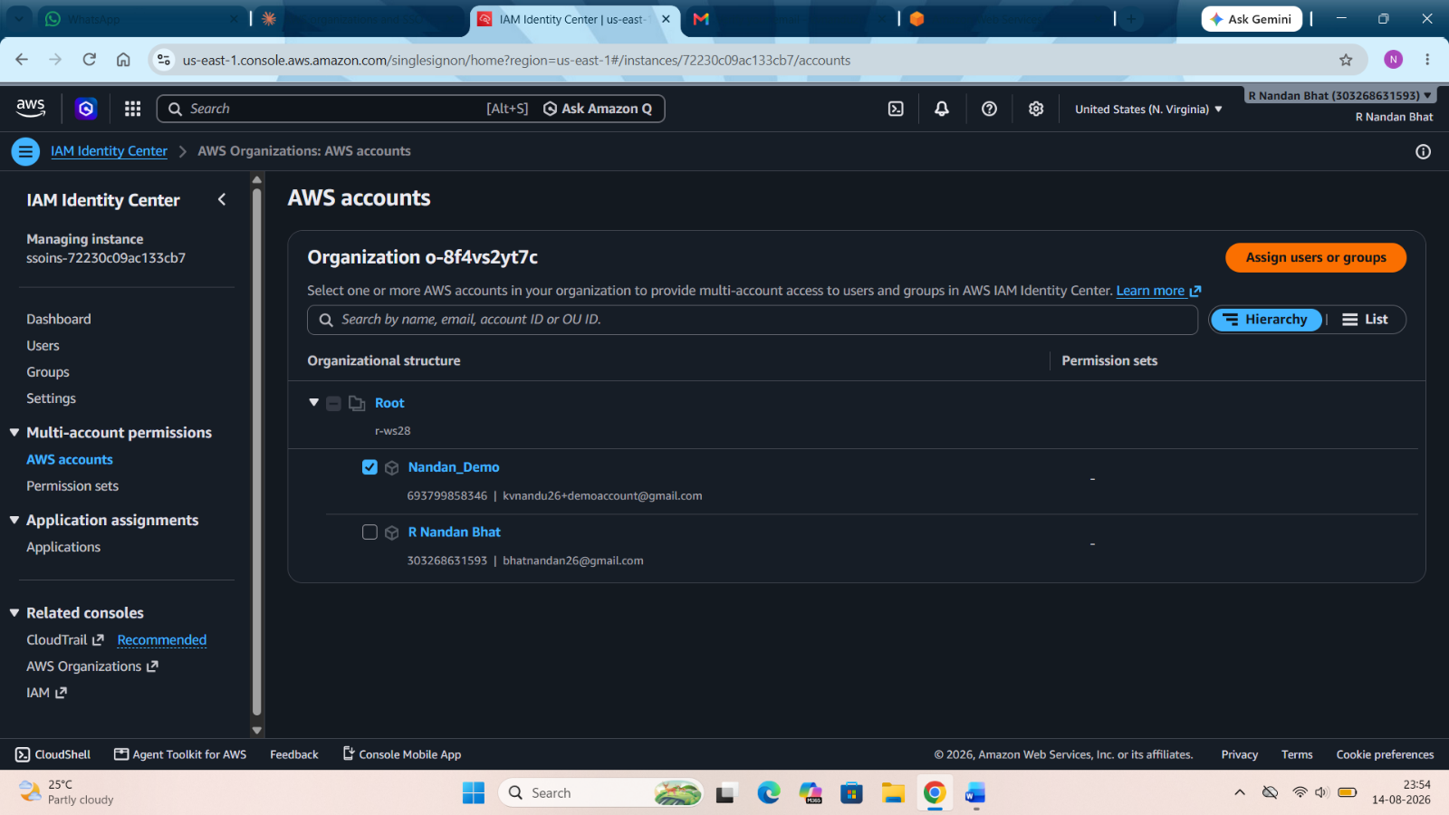

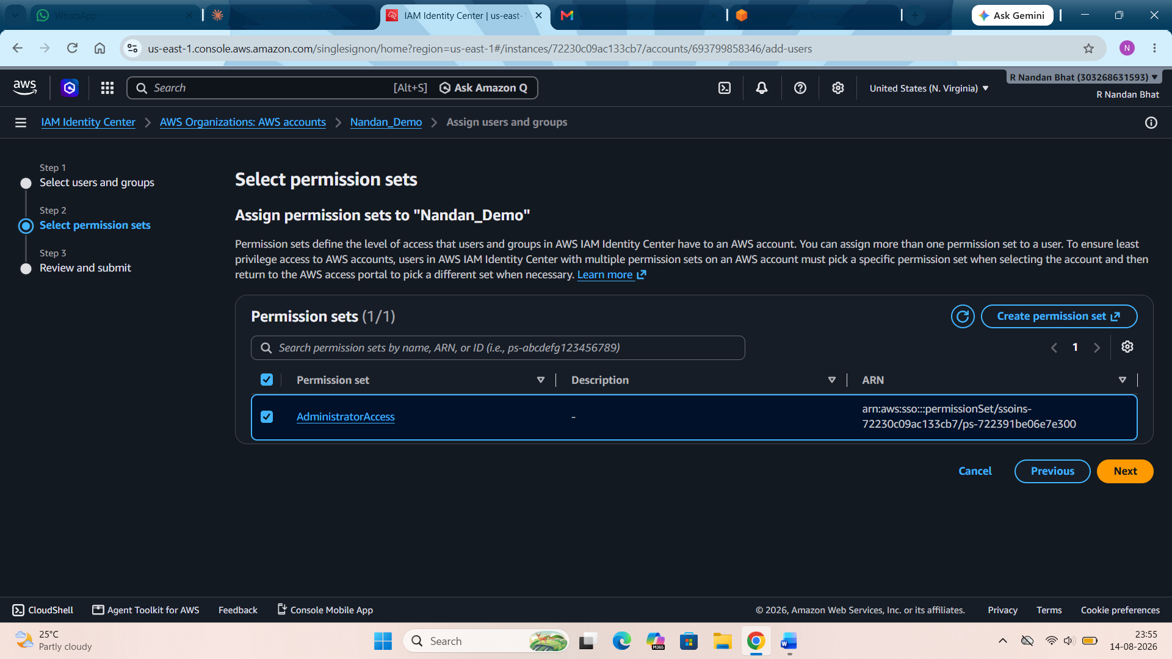
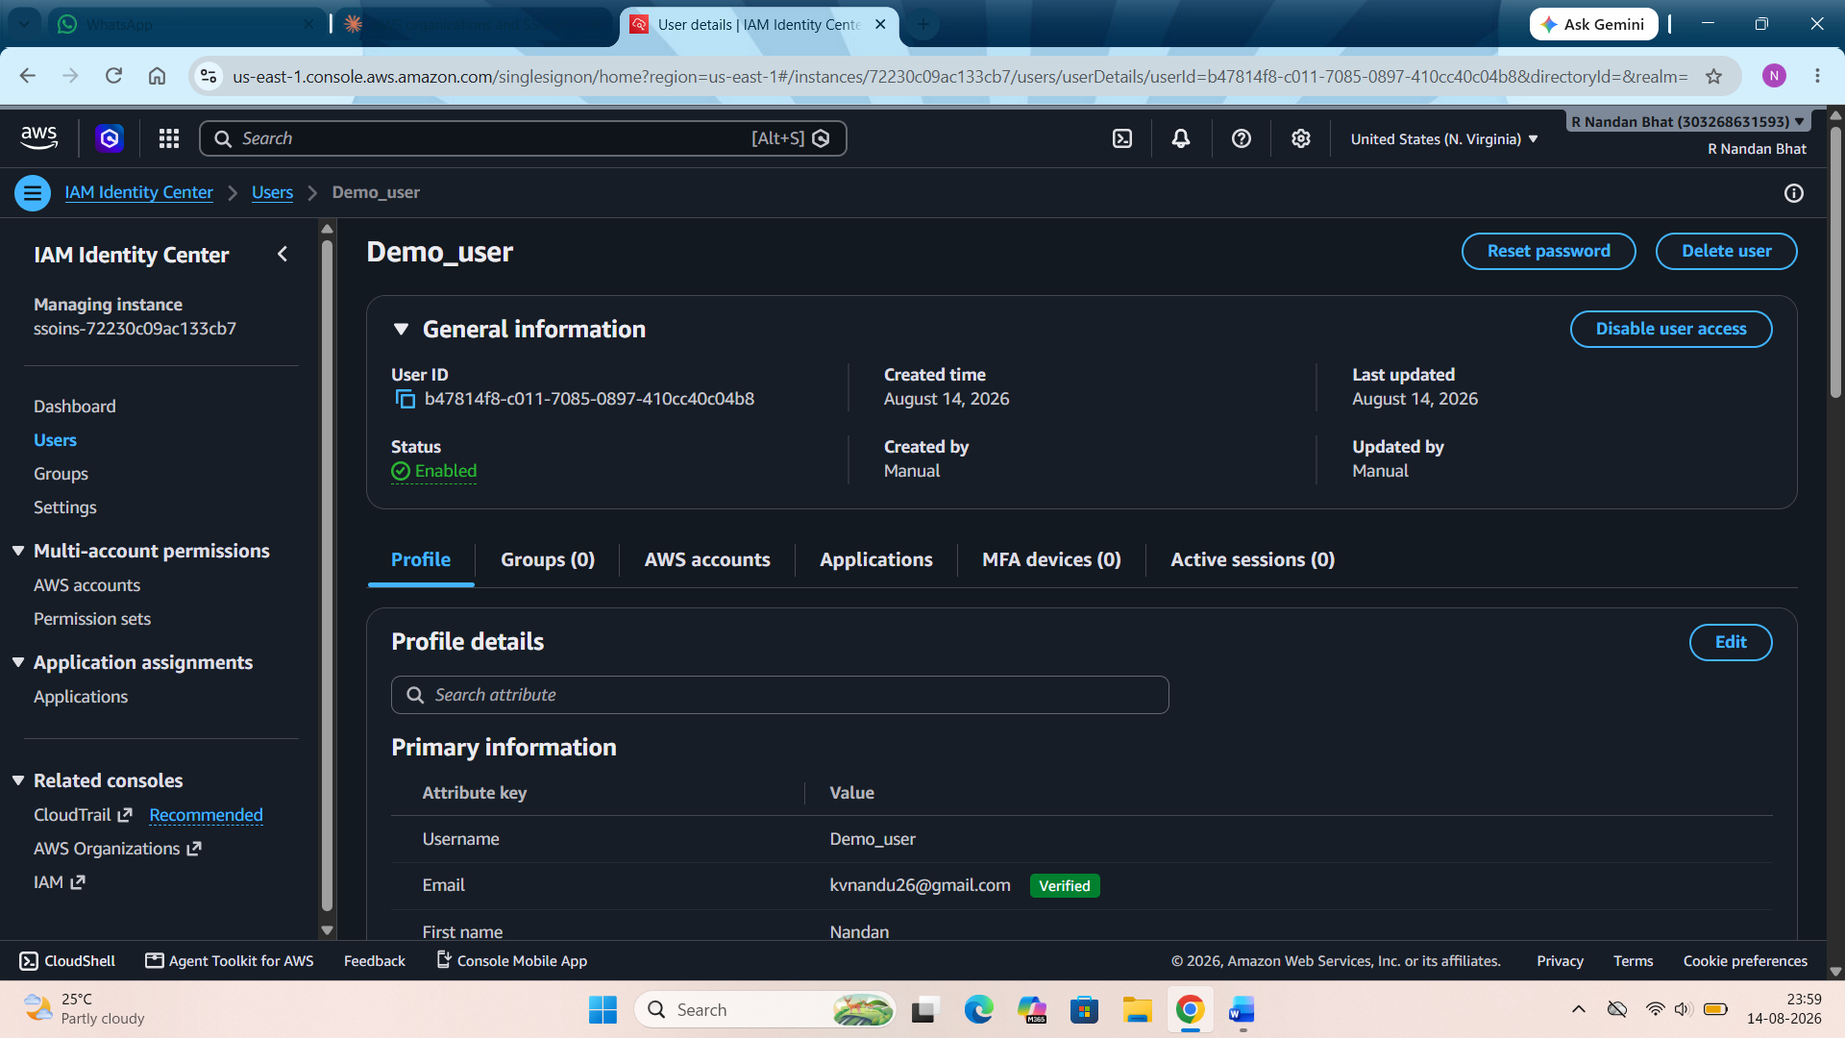
Step 7: Verify SSO in action. Open your portal URL. Log in with username and password that we set up. Here it will show your member account listed with AdministratorAccess as an available role.
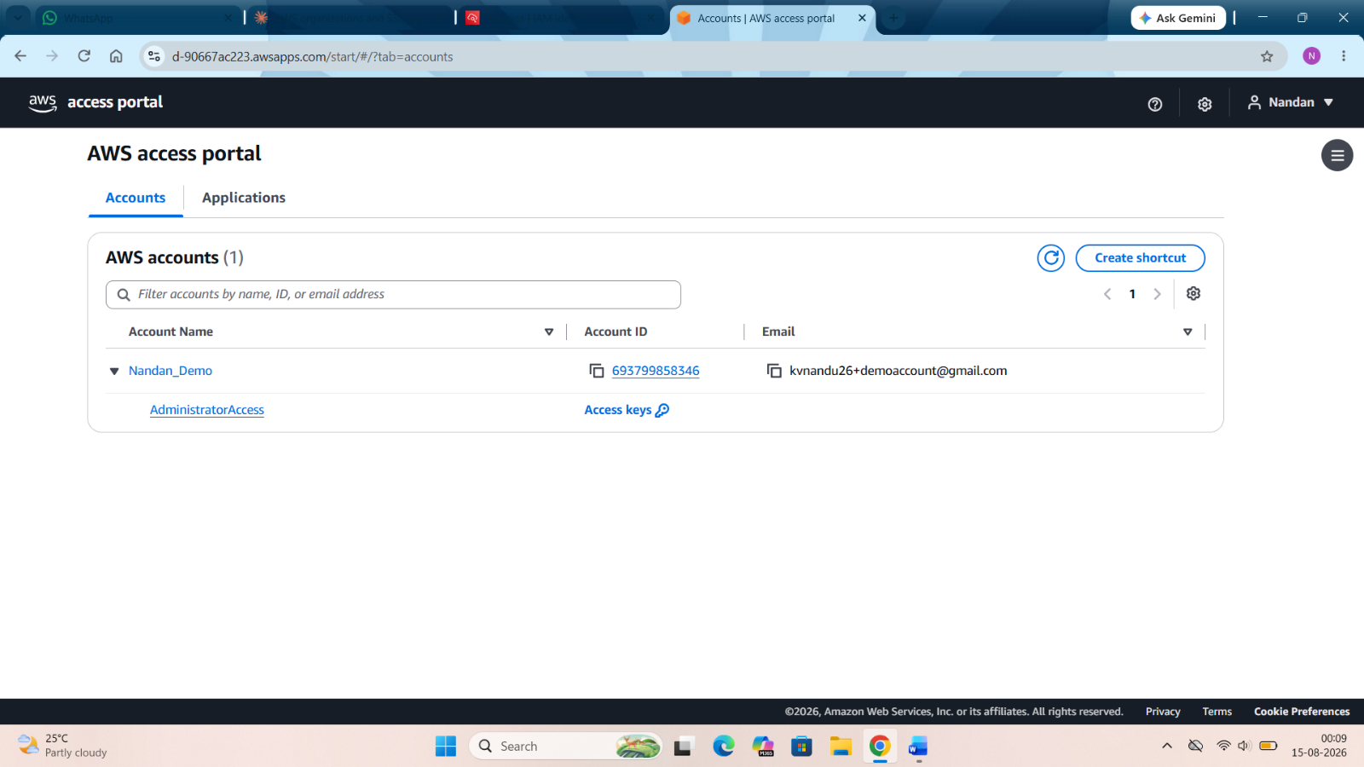
Click on the account name to expand it, then click AdministratorAccess to actually log into that account's AWS Console. Once the console opens, check the top-right corner. It should show the member account's name/ID.

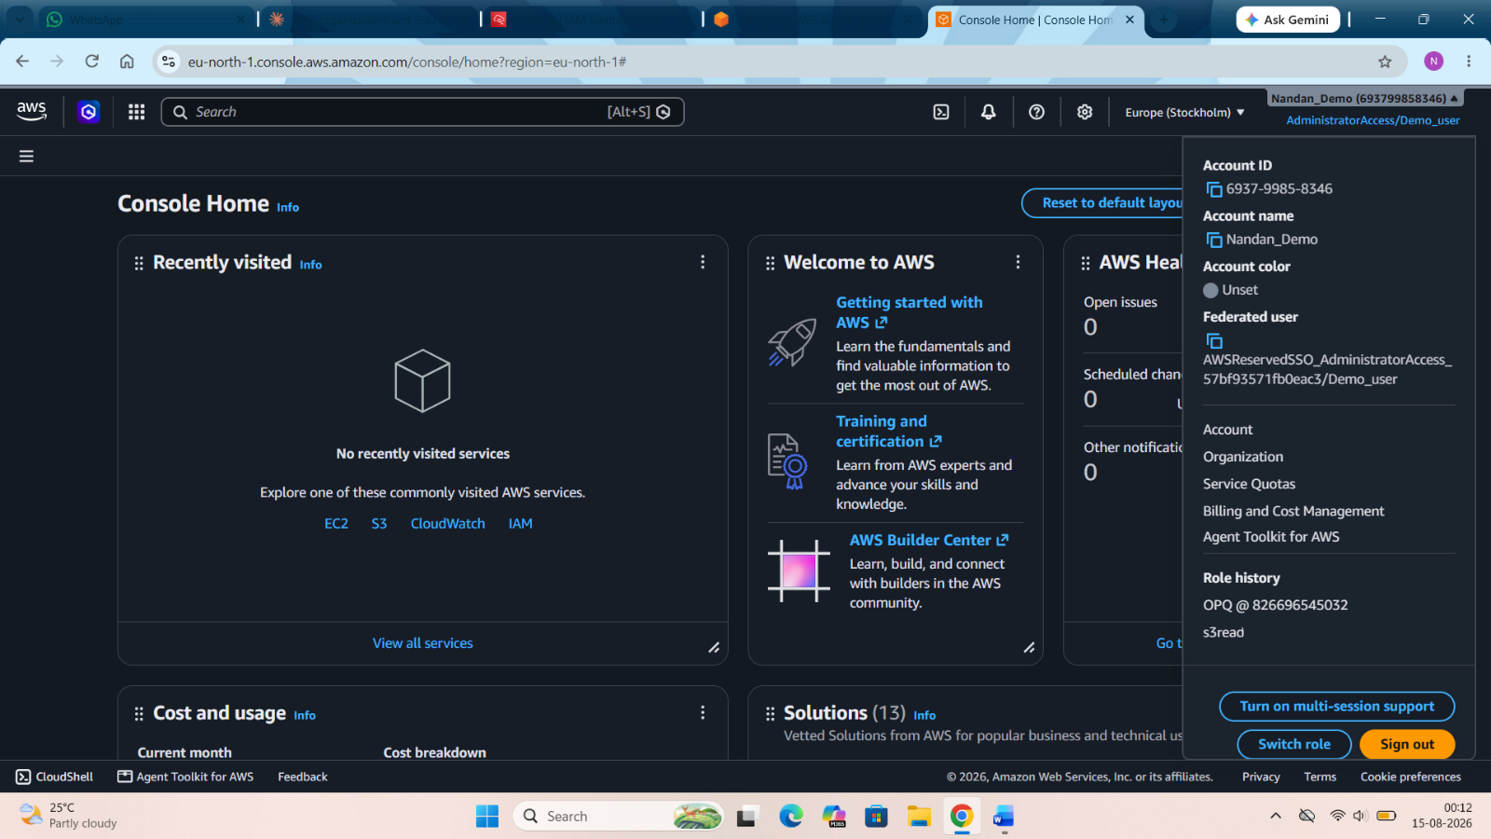

Clean up:
Remove everything you created and the organization itself.

